OneDrive * SharePoint * O365

One Drive
- What is it?
- Where is it?
- Upload
- Download
- Share
- Send to SharePoint
SharePoint
- Calendar
- Announcements
- Documents (this is a great place to share)
O365
- Mail
- OneDrive
Having issues?
Call our help desk at 686-4329!

- SharePoint
- Calendar
- People
- Forms

One Drive

What is it?
  - A cloud-based file storage system
  - What does that mean for you?
    - All files saved under your OneDrive can be accessed from anywhere that you can log-in to your 0365: home, cell, work, etc.
  - Benefits of OneDrive:
    - Computer crashes? All files are safely stored in the cloud.
    - Server crashes (losing your H: drive)? All files are safely stored in the cloud.

Where is it: (How to get to it through the “waffle”)
  - To see your files through your waffle, simply log-in to your O365 account (your email) and click on the little waffle symbol. Colors may vary depending on your settings.
  - Your waffle will show several apps that can be used. Your OneDrive app looks like a cloud.

How to Upload
- Click on “Upload” at the top and choose to upload a file or a folder (if “folder” is not an option, try opening O365 using Google Chrome). If there were problems with a document uploading, you will get this notification up at the top. By clicking on the X, it will tell you which item and the issue.
- When uploading multiple items, it may take a little while. To know it’s working, check the top right hand corner and you will see how many items it is uploading.
How to Download
- To Download, select the document, then select the ellipsis that appears:
- This will provide a dropdown menu with options such as download, share, delete, move to, copy, open, etc.

How to Send to SharePoint:
- Following the same instructions for download, click on the ellipsis and select “copy to” and then select your SharePoint site.

SharePoint

How to get to it:
- There is an icon on your desktop that looks like this:

- To get to it from a different computer, log-in to your O365, then click on the waffle, then on the SharePoint icon.

- If you have followed it, it will appear under your “followed” list to the left.
- If not, search for it in the search box located on the left of the screen:

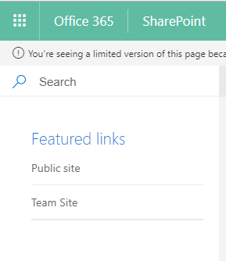

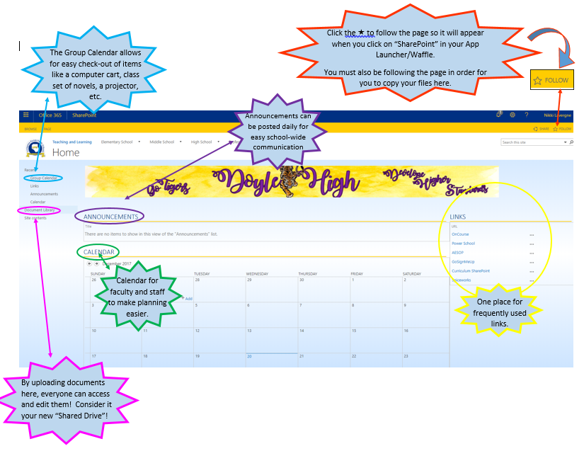

Calendar  Online calendar (s)  Calendars can be seen individually, or grouped together. | - Can add activities for more than one person.  - Can decline or accept invitations to participate.  - Can set reminders
People | Email contacts and lists  (this is where you make an e-mail contact list- not groups)
Forms | Can create “forms” which can be used as a type of survey and results are gathered in real time. Responses can come from a class, a group, the entire organization, or can even be made public.
Word  Excel  PowerPoint  Click “Open in Browser” when editing a file | - Online versions of Microsoft Word, Excel, and PowerPoint  - By editing in the online program, multiple people can edit a document at the same time.
Videos  “Channels” of uploaded videos for organizational sharing. E-mail is sent when video is done uploading. | - Easy access to videos needed for class- no need to store them on desktop, or attempt to stream.  - Allows teachers to see videos other teachers have found useful. LPPS Technology has a channel of How-To Videos!
OneNote | - Digital note taking app that collects all notes (handwritten or typed), drawings, screen clippings, and audio commentaries in “Notebooks”.  - Can create more than one notebook.
O365

