High School Weighted Grades
2021-2022

All High School Courses will use a weighted grade format for assigning student grades. Semester grades will be determined by dividing the total points earned by the total points possible by weighted categories. Letter grades will be assigned according to the different grading scales based on the type of course each student is enrolled in.

All student work to be graded will be assigned a point value and entered into one of four weighted categories.
Weighted Categories for each High School Course: | Power School Category Abbreviation | Weights for each Category:
Major Assessments | MA | 40%
Assessed for Accuracy (Quizzes, Labs, Projects, etc...) | ACC | 35%
Participation / Completion | PC | 10%
End of Semester Assessment | SEM EX | 15%

Other Grading Requirements and Procedures:

- At least two grades per week must be entered into PowerSchool.
- At least two grades per category with the exception of the End of Semester Assessment category every 4½ weeks (each interim period) must be entered into Power School.

HS GRADEBOOK SETTINGS
The categories below will be pushed out to each high school teacher and set in the teachers gradebook as the default.

SET AS DEFAULT – Pushed from the district to all high school teachers this morning. No manual changes needed.
High School weighted categories:
- Major Assessments (HS) 40%
- Assessed for Accuracy (HS) 35%
- Participation/Completion (HS) 10%
- End of Semester Assessment (HS) 15%

LAA1/A833 Category Weights

****The program only allows the district to push one set of categories out to a school so teachers with Act 833 students enrolled in an EOC class will have to manually set their gradebooks for those sections. A document will be created to walk teachers through the process. They will have to do this for every grading period.**** Teachers will have to delete the default categories that were pushed by the district before adding the new categories for weighting.
There is now an option to copy category weights from one section to another, so instead of having to reenter the categories for every grading period, teachers can just copy and paste (see instructions underneath category list).

LAA1 and Act 833 Students (Algebra I, Geometry, English I, English II, English III, US History, and Biology)
Weighted Categories for each High School Course: | Power School Category Abbreviation | Weights for each Category:
Major Assessments | MA | 40%
Assessed for Accuracy (Quizzes, Labs, Projects, etc...) | ACC | 40%
Participation / Completion | PC | 15%
End of Semester Assessment | SEM EX | 5%

Other Grading Requirements and Procedures:

- At least two grades per week must be entered into PowerSchool.
- At least two grades per category with the exception of the End of Semester Assessment category every 4½ weeks (each interim period) must be entered into Power School.

WILL HAVE TO BE SET MANUALLY
A833 categories:
- Major Assessments (A833) 40%
- Assessed for Accuracy (A833) 40%
- Participation/Completion (A833) 15%
- End of Semester Assessment (A833) 5%

LPPS has pushed categories to all HS PowerTeacher gradebooks. For all A833 classes, the categories must be changed.
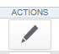
To change categories, get into PowerTeacher Pro and into an A833 class gradebook. Then click on Settings, and select Traditional Grade Calculations.
Click the pen under Actions for S1

Delete all other categories by clicking the minus sign. It will keep one category until another is added (see below)
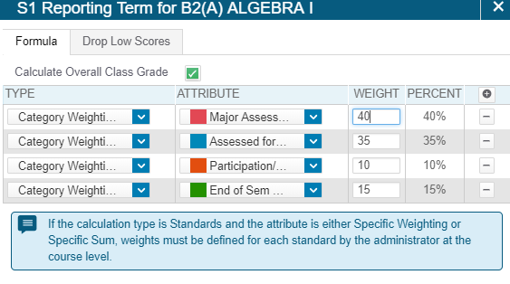
To add the correct categories, click the plus sign, change “Total Points” to Category Weighting and select one of the A833 categories. Then you can delete the last category that was there previously.
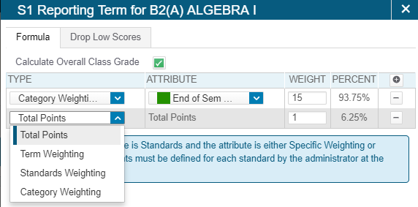
Finished look:
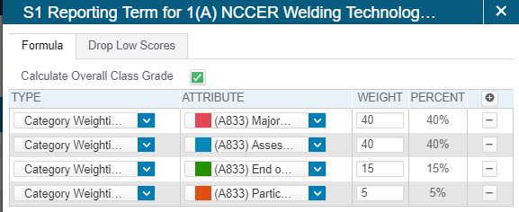
Add the rest of the A833 categories and set the appropriate weights.
- Major Assessments (A833) 40%
- Assessed for Accuracy (A833) 40%
- Participation/Completion (A833) 15%
- End of Semester Assessment (A833) 5%

Be sure to hit save!

Now that Semester 1 has been set, all other A833 grading periods must be set to the same.

To do this, after you have ALL of the categories set and saved, click the settings gear, then “Copy Traditional Grade Calculations”.

Select “Within A Class”, then choose the class, then the reporting term from which category calculations are set.
Then select all reporting terms to change their current categories to the correct ones, then hit “Validate”.
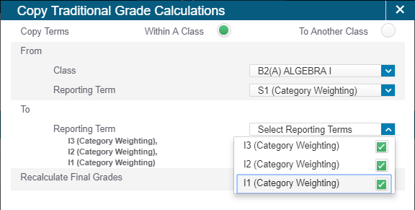

If there are more A833 classes, follow the same steps, but select “To Another Class” and select the other A833 classes.

Just to clarify: The only teachers that will have to manually set the category weights will be teachers who have Act 833 students enrolled in an EOC class. ALL other high school classes follow the district weighting in order to comply with PPP. This includes dual enrollment classes. Students in DE course have 2 grades one for HS and one for college. The HS grade (PS grade) should follow the HS weighted categories in order to be in compliance with pupil progression. The college grade can be on different weighting.

Teacher Assessment Tool

Other Grading Requirements and Procedures:

- At least two grades per week must be entered into PowerSchool.
- At least two grades per category with the exception of the End of Semester Assessment category every 4½ weeks (each interim period) must be entered into Power School.

Sample Assessments for each Category:
- Major Assessments (MA)
(Measures Full Intent of the Standard or Standards / Mastery of the Standard or Standards)

- Chapter Test
- Clinical/Internship Assignments
- Constructed Response or
Document Based Question
-LEAP 360 Interim Assessment

- Cumulative Quiz over several
standards or sections
- EAGLE Assessment
- Embedded Assessment
- End of Unit Test

- Essay
- SLT Checkpoint Assessment
- Socratic Seminar
- Student Portfolios
- Unit Project/Presentation
- Assessed for Accuracy (Quizzes, Labs, Projects, etc...) (ACC)
(Piece of the Standard or Skills within a Standard or Standards are Assessed)

- Bell Ringer Quiz
- Exit Ticket (graded for
correctness)
- Project or Portfolio Checkpoint
-LEAP 360 Interim Assessment
- Section Quiz
- Standard Based Performance
Task
- Standard Based Presentation
- Standard Based Project
- Standard Based Quiz
- Standard Based Task or Lab
- Standard Based Worksheet

- Participation / Completion (PC)
(Effort, Participation, or Completion of Work Assessed)

- Completion of Classwork
- Completion of Daily Bellringer
- Completion of Homework
- Daily Journal
- Group Participation
- Self-Assessment

- Teacher Checklist
- Teacher Observation
(4)End of Semester Assessment (SEM EX)
(Semester or Course Standards Assessed)

- Certification Exam
- End of Course Test/LEAP 2025 (EOC)
- Final Exam
- Midterm Exam

- Proficiency Test

STUDENT INFORMATION FOR WEIGHTED GRADES

GRADING PROCEDURES
Students will receive two report cards, one at the end of each semester. The report card will be a cumulative grade of the entire semester’s work based on weighted grades per subject. Grades will be weighted to include Major Assessments (MA), Assessed for Accuracy (Quizzes, Labs, Projects, etc...)(ACC), Participation/Completion (PC), and End of Semester Assessment (SEM EX). In a 100% grading system, MA will carry a weight of 40%, of the total grade. ACC will carry a weight of 35%, of the total grade. PC will carry a weight of 10%, of the total grade. SEM EX will carry a weight of 15%, of the total grade. For LAA1/Act 833 Students (Algebra I, Geometry, English I, English II, English III, US History, and Biology), MA will carry 40% of the total grade. ACC will carry 40% of the total grade. PC will carry a weight of 15% of the total grade. SEM EX will carry a weight of 5% of the total grade.
Three interim reports will be issued each semester: 4 ½ weeks, 9 weeks, and 13 ½ weeks. Interim grades are cumulative as well. When calculating percentages to determine a letter grade, .50 and above will always be rounded off to the next highest number. GPA’s are not rounded! It is strongly encouraged to check your PowerSchool grades at: http://powerschool.lpsb.org/teachers/pw.html If you need your login information, please contact your home school.

CALCULATING WEIGHTED AVERAGES
In cases where grades do not share the same weight, (ie. when multiple grading categories exist), the calculation is different. The weight of each grade category must be taken into account. Individual grades might also be worth different amounts within a given category. http://gradegrid.com/articles/grading/how-to-calculate-weighted-grade-average
Consider the following example:

Grade Categories
Category Example | Weight | Weight for LAA1/ACT 833 students
Major Assessments (MA) | 40% | 40%
Assess for Accuracy (ACC) | 35% | 40%
Participation/Completion (PC) | 10% | 15%
End-of-Semester Assessment (SEM EX) | 15% | 5%

Student Grades
Category Example | Grade 1 | Grade 2 | Grade 3
Major Assessments (MA) | 50/60 | 45/50 | 92/100
Assess for Accuracy (ACC) | 55/75 | 43/52 | 78/100
Participation/Completion (PC) | 9/10 | 8/10 | 7/10
End-of-Semester Assessment (SEM EX) | 80/120

TO CALCULATE THE WEIGHTED AVERAGE, YOU NEED TO DO THE FOLLOWING:

1. Calculate the grade average within each category.
Individual Category Averages
Category Example | Calculation | Result
Major Assessments (MA) | (50 + 45 + 92) / (60 + 50 +100) | .89
Assess for Accuracy (ACC) | (55 + 43 + 78) / (75 + 52 + 100) | .78
Participation/Completion (PC) | (9 + 8 + 7) / (10 + 10 + 10) | .80
End-of-Semester Assessment (SEM EX) | 80/120 | .67

2. Multiply each category average by its corresponding weight.
Category * Weight
Category | Calculation | Result
Major Assessments (MA) | .89 * 40 | 35.6
Assess for Accuracy (ACC) | .78 * 35 | 27.3
Participation/Completion (PC) | .80 * 10 | 8
End-of-Semester Assessment (SEM EX) | .67 * 15 | 10.1

Category * Weight (for LAA1/ACT 833 Students)
Category | Calculation | Result
Major Assessments (MA) | .89 * 40 | 35.6
Assess for Accuracy (ACC) | .78 * 40 | 31.2
Participation/Completion (PC) | .80 * 15 | 12
End-of-Semester Assessment (SEM EX) | .67 * 5 | 3.4

3. Add the weighted categories together and divide by the sum of the weights.
Overall Average
Calculation | Result | Result for LAA1/ACT 833
(35.6 + 27.3 + 8 + 10.1) / 100 | .81
(35.6 + 31.2 + 12 + 3.4) / 100 |  | .82
Congratulations, you now know that the student scored an overall grade of 81% C (82% for LAA1/ACT 833 student).

