How to Create an E-mail Contact List

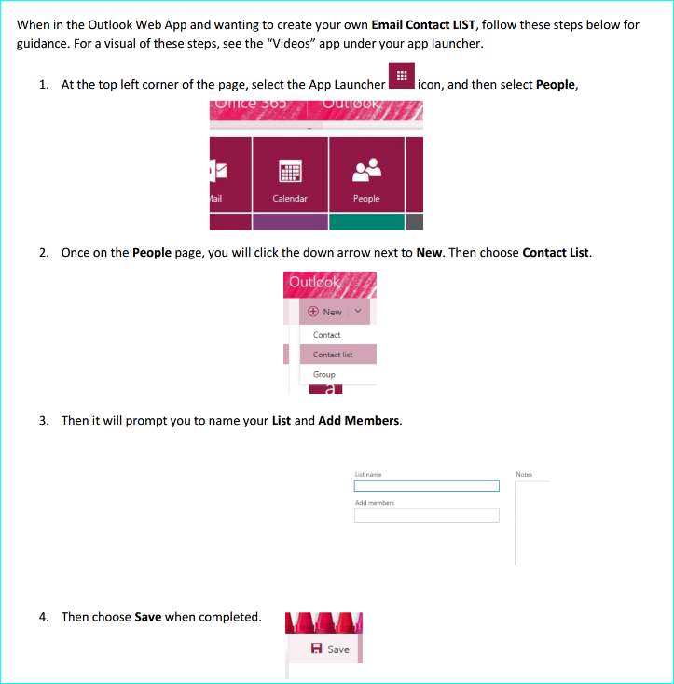

All contact lists created by the district will start with “LPPS_”