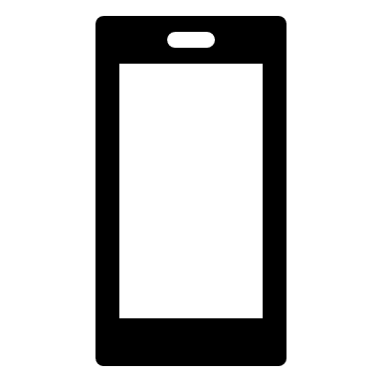
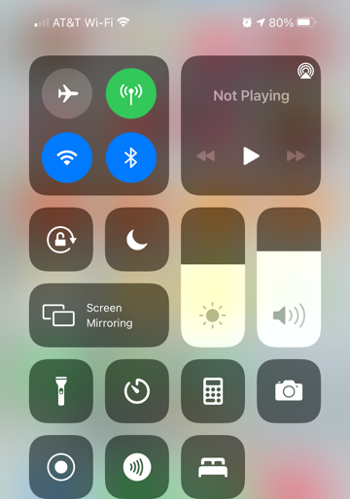
LOCATION AV System
To connect via iPhone:
- Connect to NIKKI wifi
  - PW: Presenter
- Swipe up for “screen mirroring”
- Select the NIKKI option and screen mirroring begins automatically.
- To stop, click “stop mirroring” at the bottom (you may need to swipe up again to access the screen mirroring options again).
**Note: by beginning to mirror the screen, you will kick off whomever is currently connected
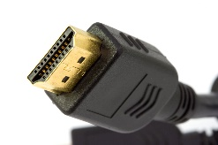
HDMI cord
To connect via laptop:
Display options
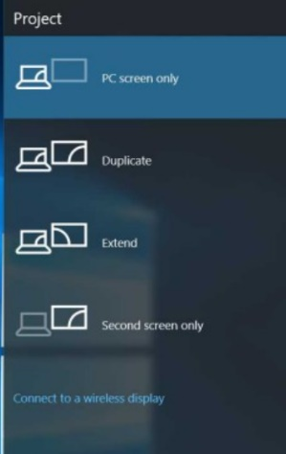
- Staff use HDMI cord to plug directly into projector
- Press the Window Key + P to get presentation display options
  - PC screen only- projector remains blank, computer displays
  - Duplicate- projector and computer screen are the same
  - Extend- Projector is like a second screen- you can drag windows to this second screen, your computer screen will not be displayed
  - Second screen only- computer screen is black and projector screen displays
- Guests use the NIKKI wifi
  - Press Window Key + P
  - Connect to Wireless display
  - Select the NIKKI option
**Hint: to make black bar go away, click thumb tack to remove
 | Sound is controlled by laptop or phone, not projector.
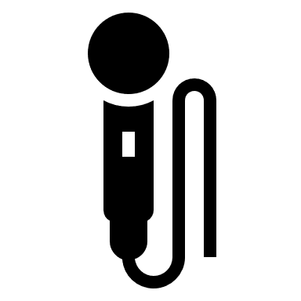 | Portable Mic is to be worn on the shirt, not at the throat  - Batteries are rechargeable; after use, place back on charging dock
 | To see videos of how to cast, go to atlona.com/casting

